**Submission Instructions:**

Your submission for this activity should be a Word document that includes the following screenshots, each labeled for the step that the screenshot represents:

1. Provide a screenshot of your Terminal window response to show that you correctly pulled the Airflow file.

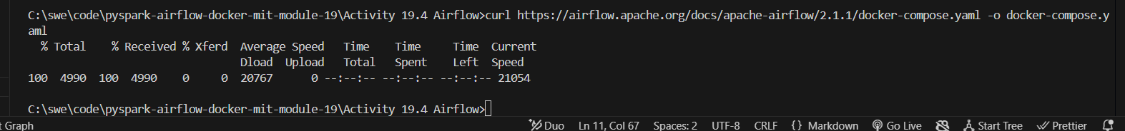

1. Provide a screenshot to show the changed example value (AIRFLOW__CORE__LOAD_EXAMPLES set to false).

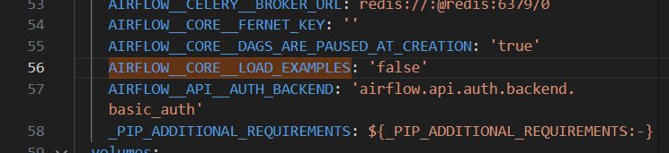

1. Provide a screenshot of the Docker window to show that Airflow is running.

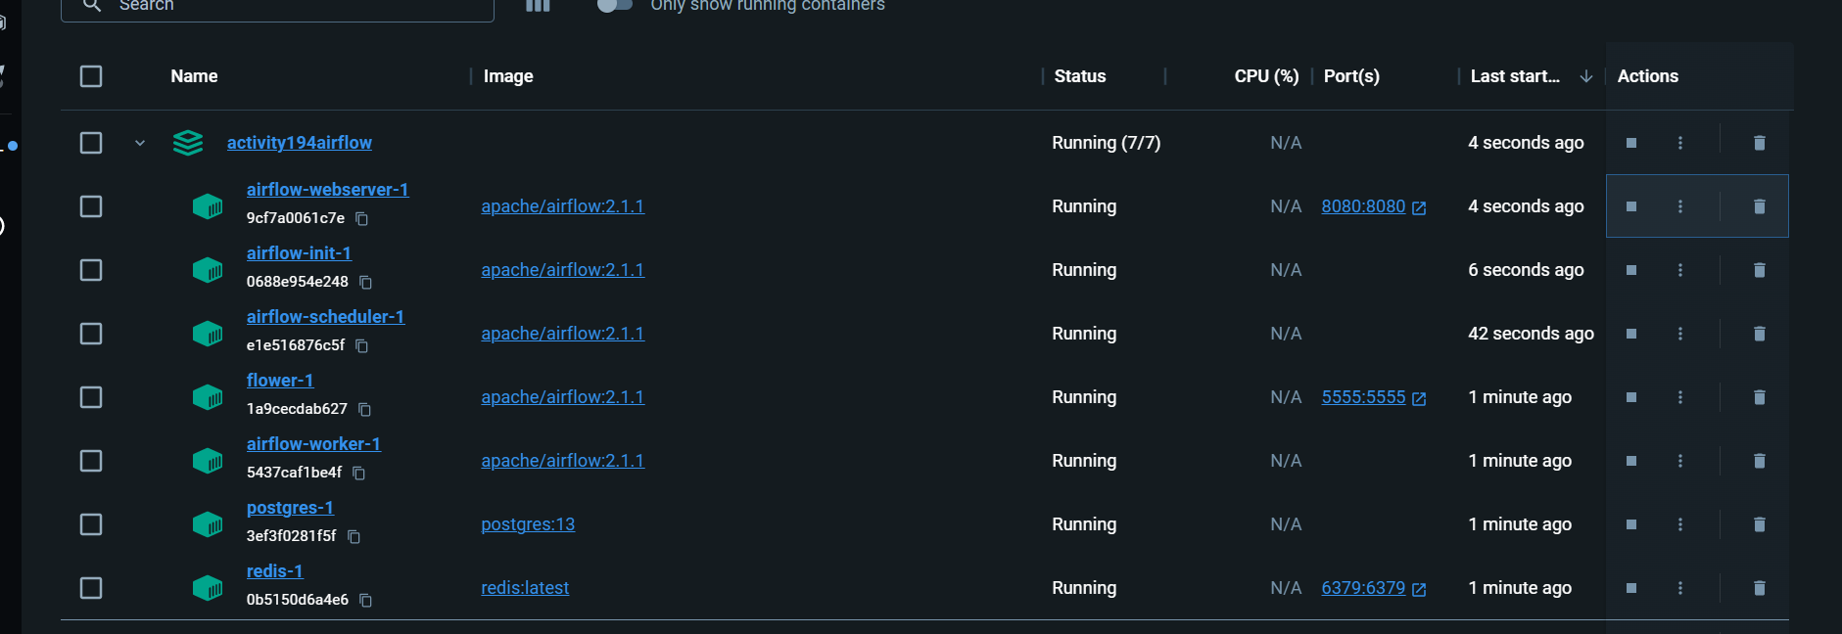

1. Provide a screenshot of your browser window to show that you have successfully logged in to Airflow.

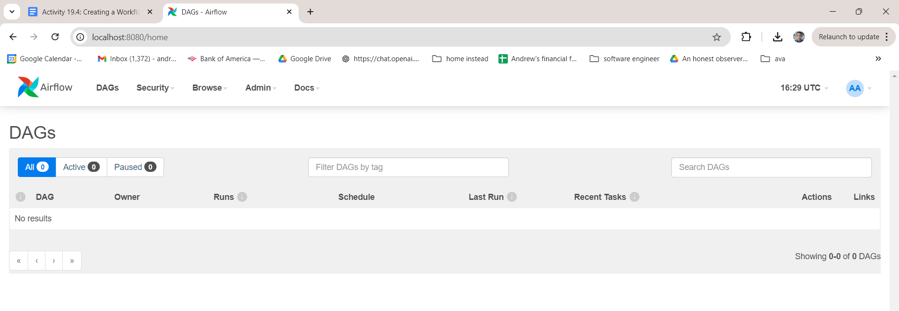

1. Provide a screenshot of the dags folder to show that the file is present.

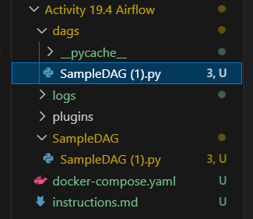

1. Provide a screenshot to show that the hello_world DAG is successfully displayed in your Airflow window.

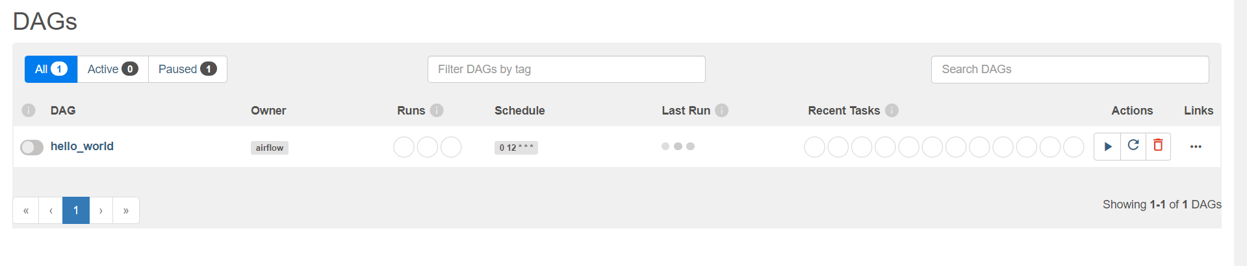

1. Provide a screenshot of the log to show that the DAG ran successfully.

